**Step by Step Screen shots**

PLAN

1. home page.

2. live tweet analysis.(2 tabs)

3. analysis of past tweets.(4 tabs)

4. build up predictive model using past tweets.

Ibm services:

1. node-red

2. ibm-watson studio - notebook

3. ibm tone analyzer

4. cloud object storage

5. cloudant

6. ibm-watson assistant.

7. db2

Python libraries:

1. twarc (dehydartion and hydration of tweets)

note: data refinery, smartinternz platform(time)

**SCREENSHOTS:**

M1) PROJECT PLANNING AND KICKOFFS:

i) **CREATING TEMPLATES**

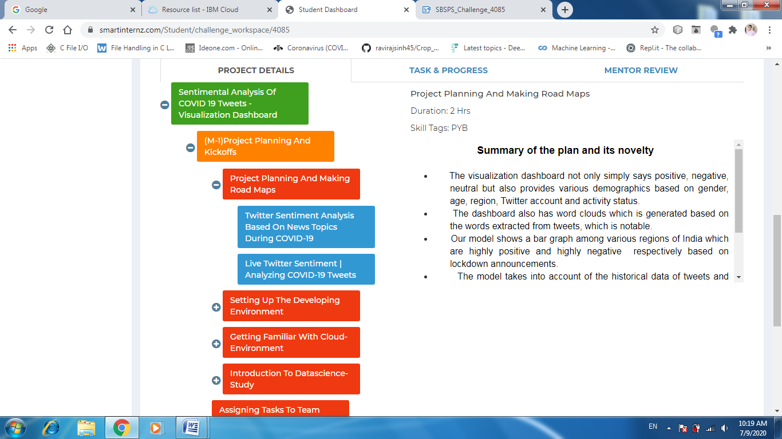

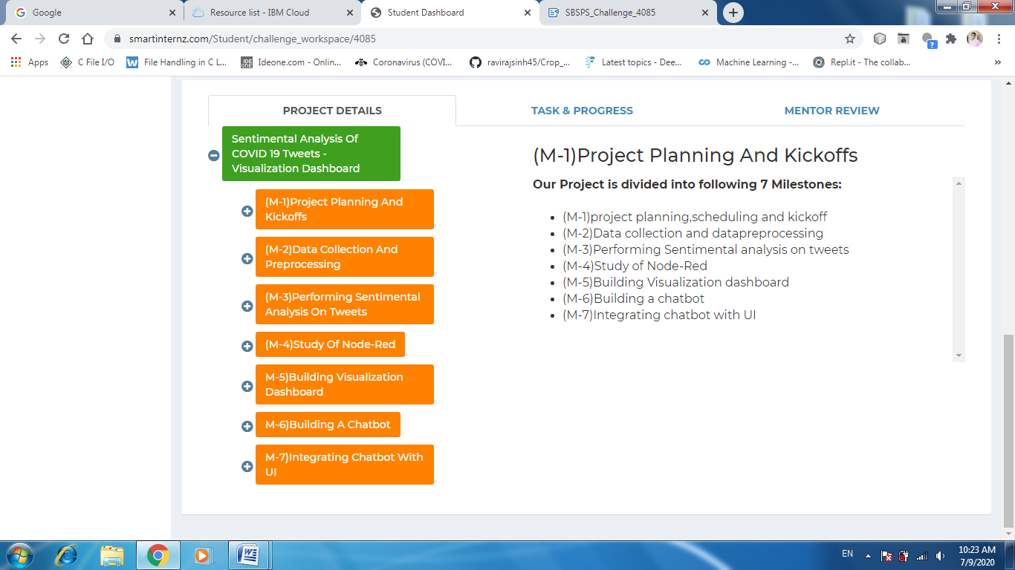

**ii)CREATING REQUIRED SERVICES:(NODE-RED AND WATSON STUDIO)**

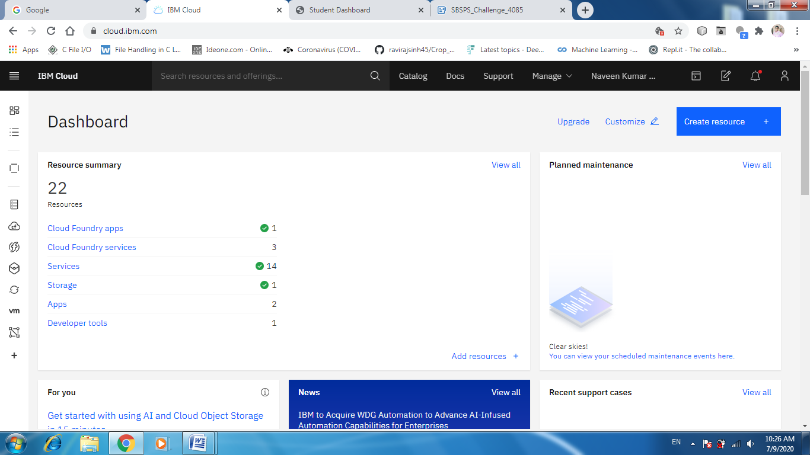

**CREATING A PROJECT IN WATSON STUDIO AND ADDING COLLOBARATORS:**

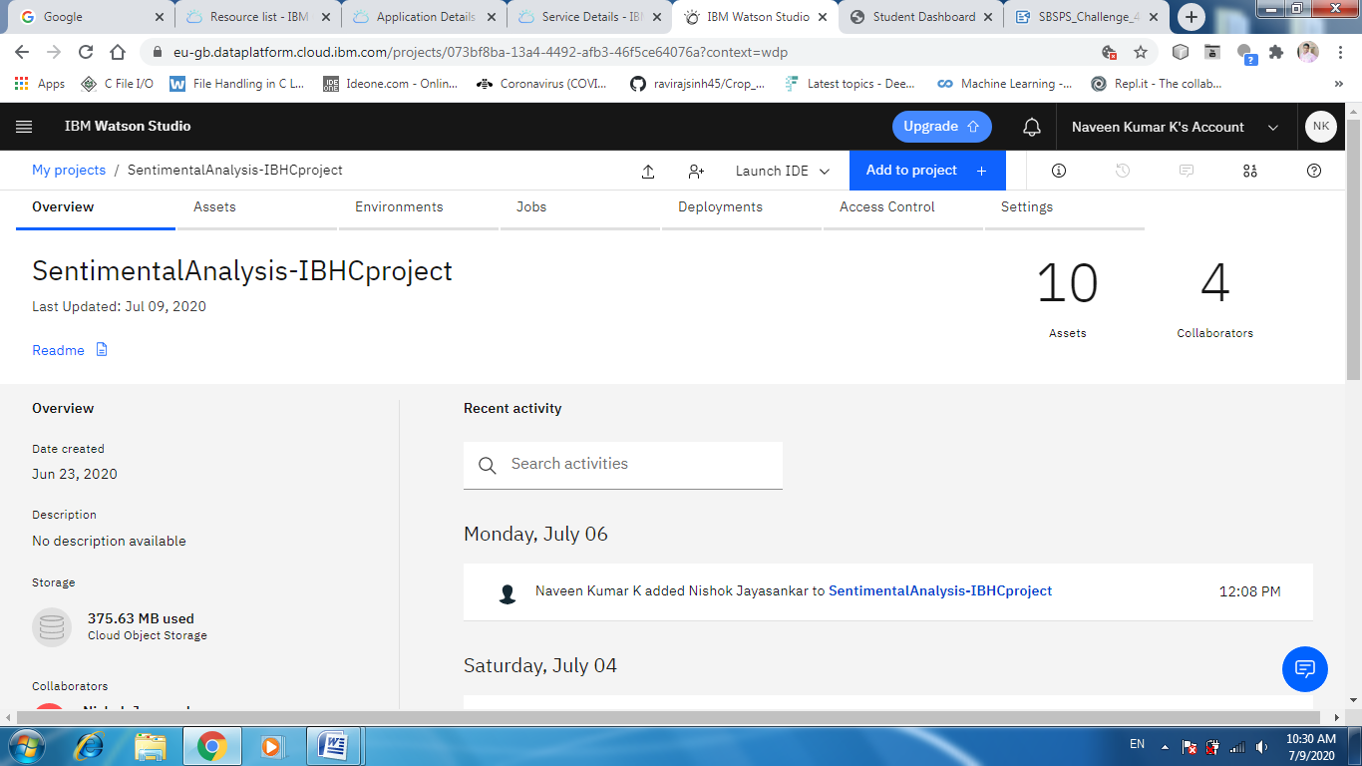

**CREATING NODE RED INSTANCE WITH REQUIRED MEMORY:**

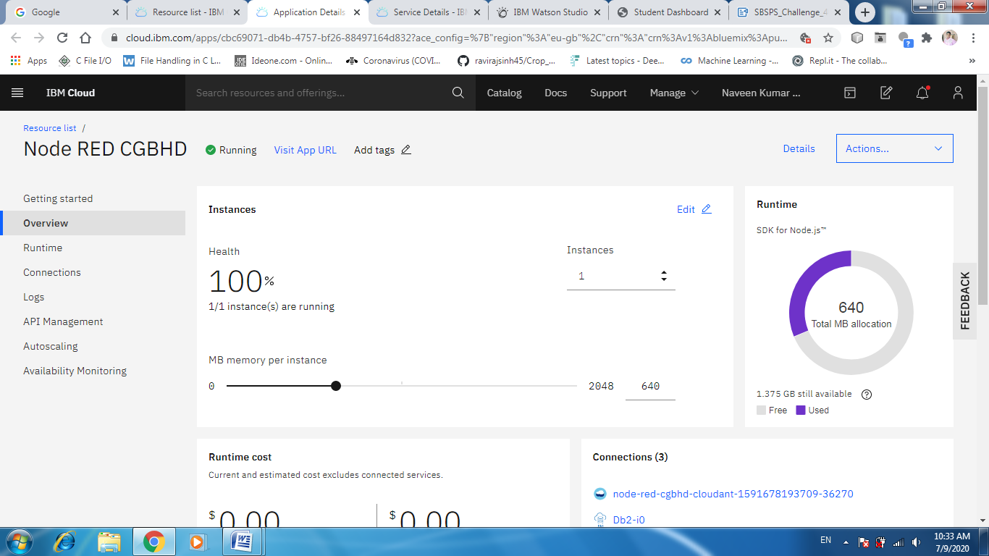

iii)COMPLETING  INTRO TO CLOUD COURSE IN COGNITIVE AI

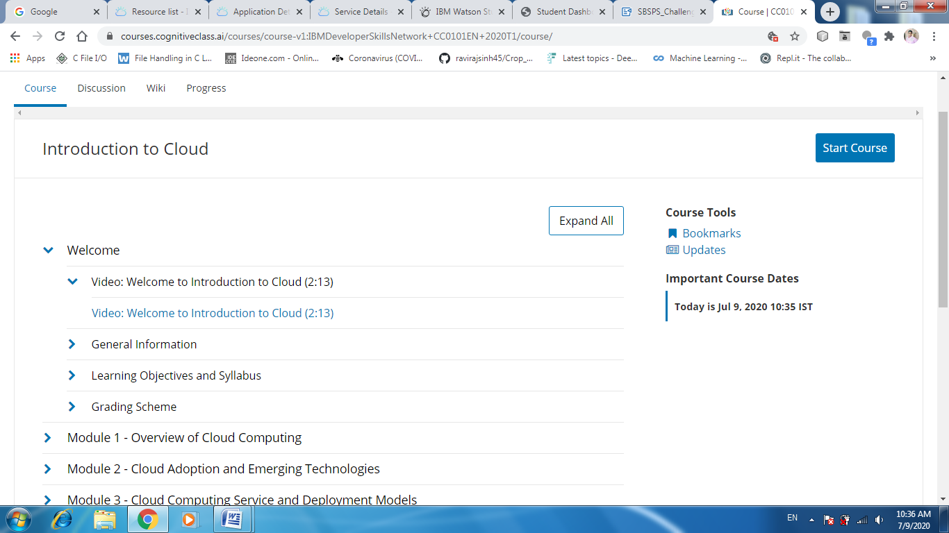

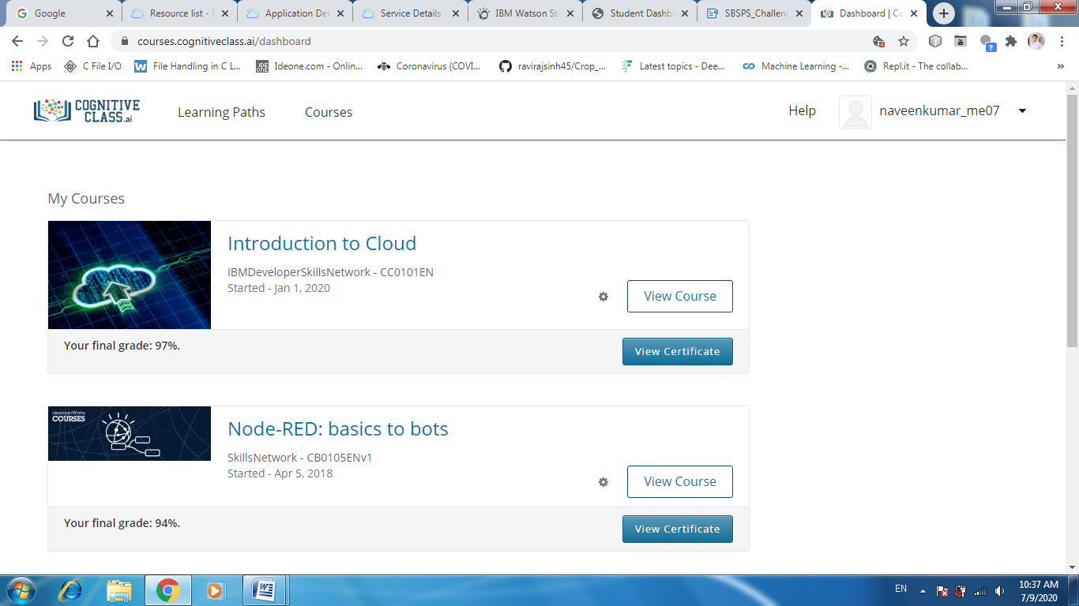

iv)COMPLETING  INTRO TO DATA SCIENCE IN COGNITIVE AI

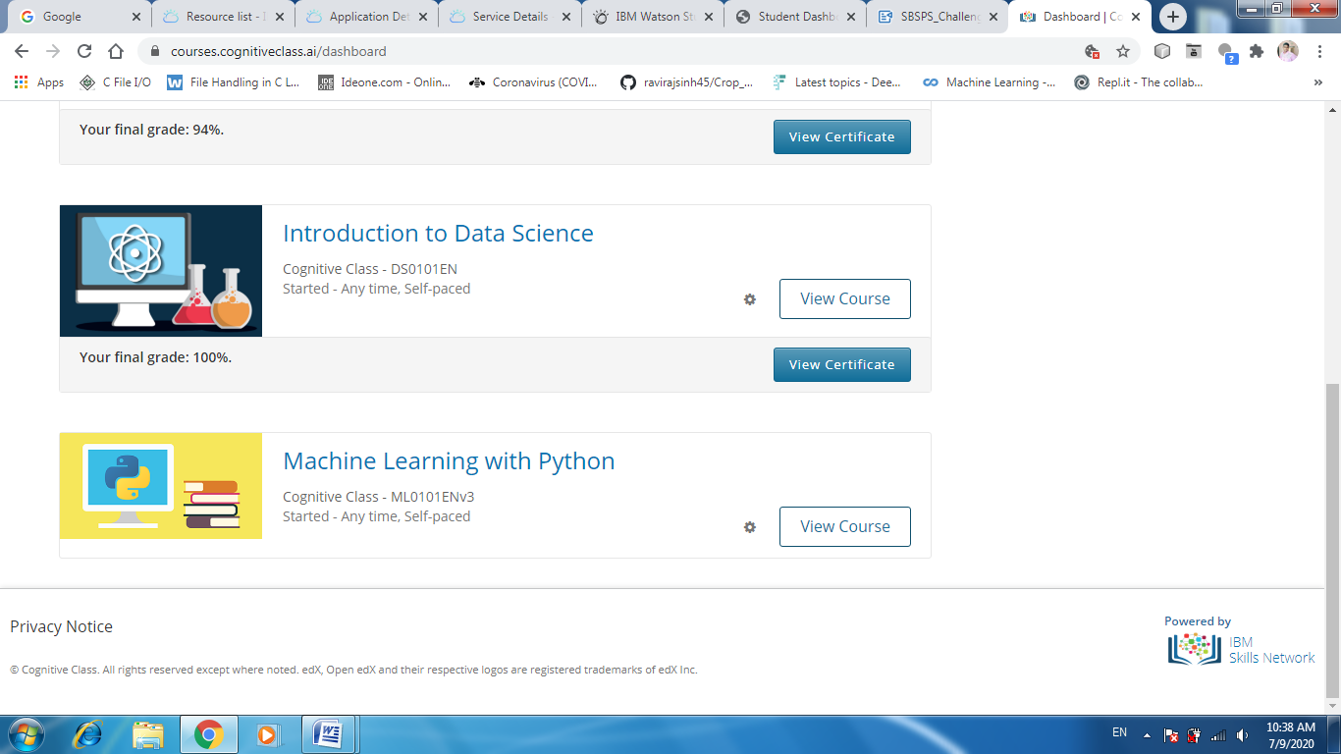

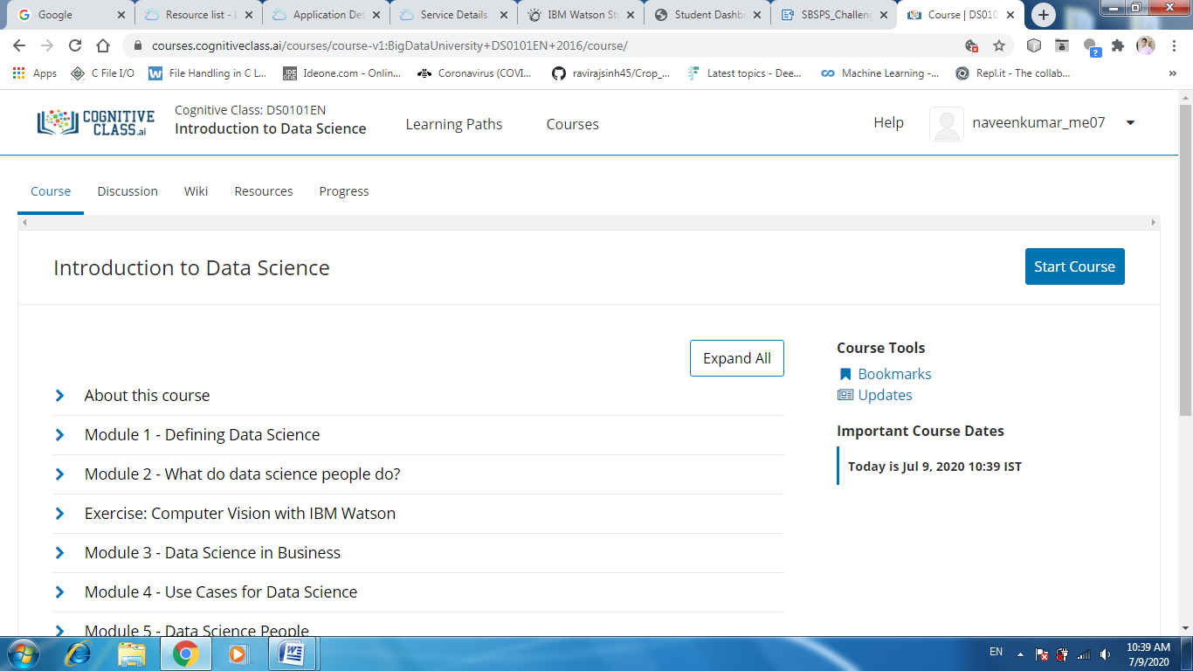

v)TRACKING AND DISCUSSING ABOUT TEAM AND INDIVIDUAL TASKS

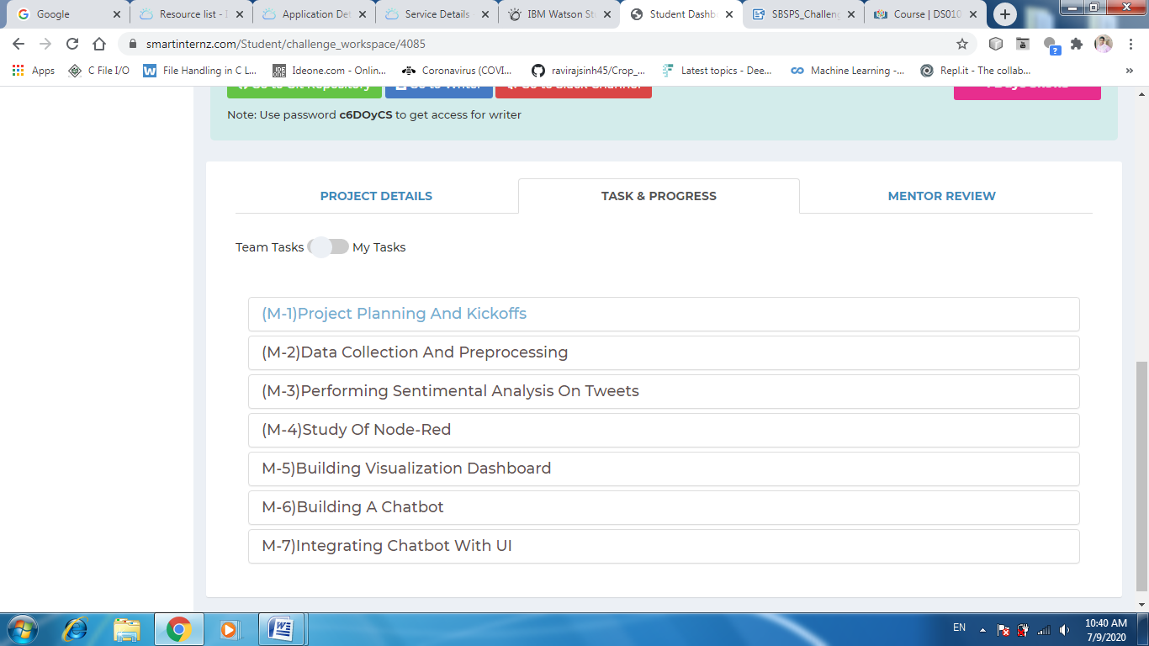

**M2)DATA COLLECTION AND PRE PROCESSING**

**TIMELINE OF LOCK DOWN:**

Phase 1 : 25 March – 14 April  
Phase 2 : 15 April – 3 May  
Phase 3 : 4–17 May  
Phase 4 : 18–31 May  
Phase 5 : 1–30 June

Here, for current scope We will only  beanalyzing the tweets on 16th April,2020 i.e a day after Phase-2 was declared to see the sentiment of the people.

DATA COLLECTION

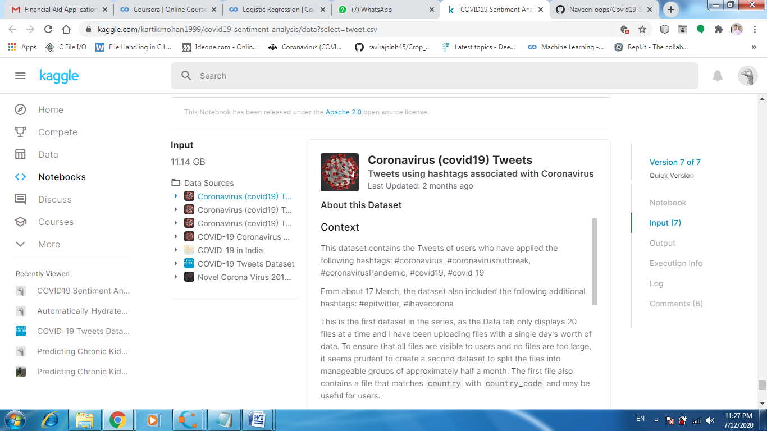

**RUNNING NOTEBOOK ON KAGGLE KERNEL:**

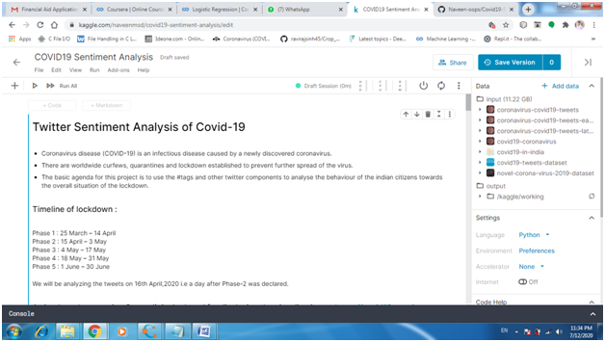

READING DATA FROM INPUT KAGGLE DATASETS

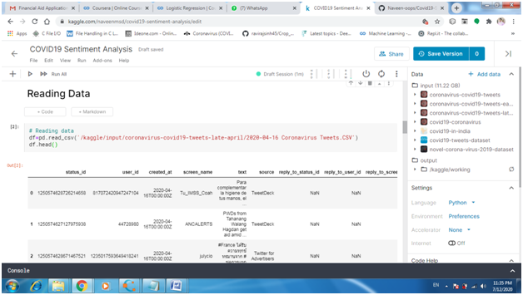

**DATA CLEANING AND PREPROCESSING**

DATA CLEANING(REMOVING UNWANTED COLUMNS):

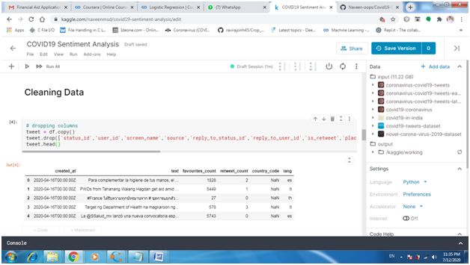

DATA PREPROCESSING

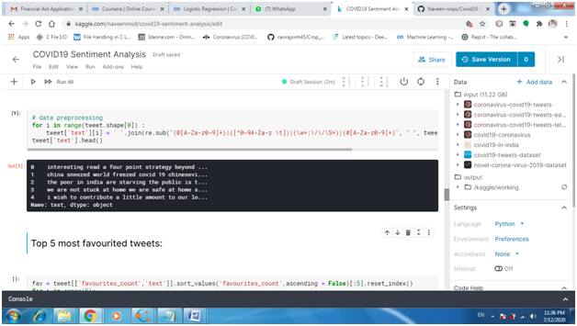

**M3)PERFORMING SENTIMENTAL ANALYSIS OF TWEETS**

EXTRACTING TWEETS AND USING TEXT BLOB FOR SENTIMENTAL ANALYSIS

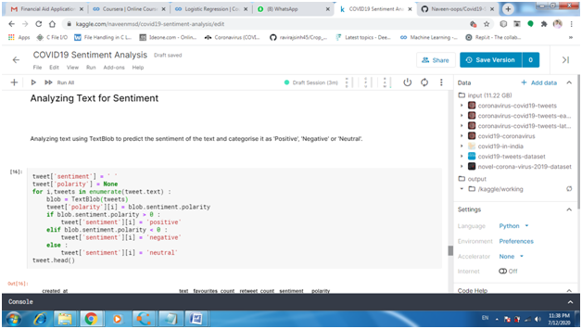

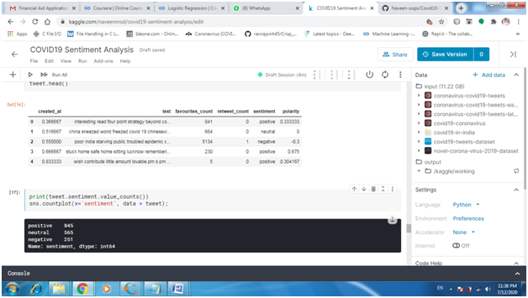

FORMING WORD CLOUDS:

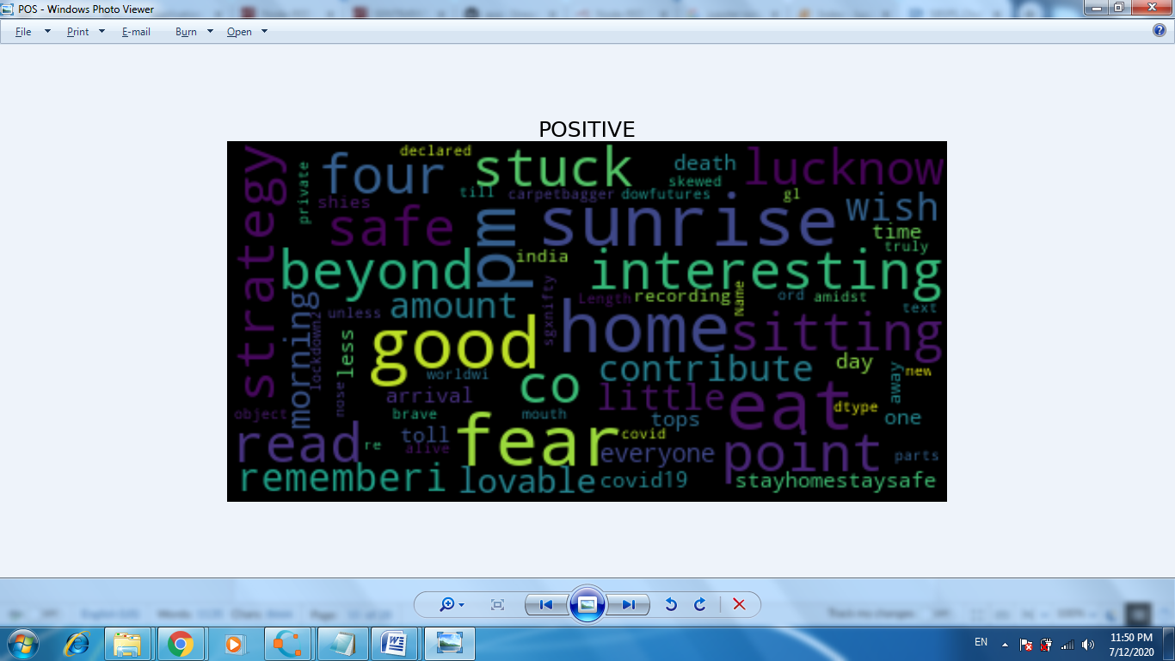

WORD FREQUENCIES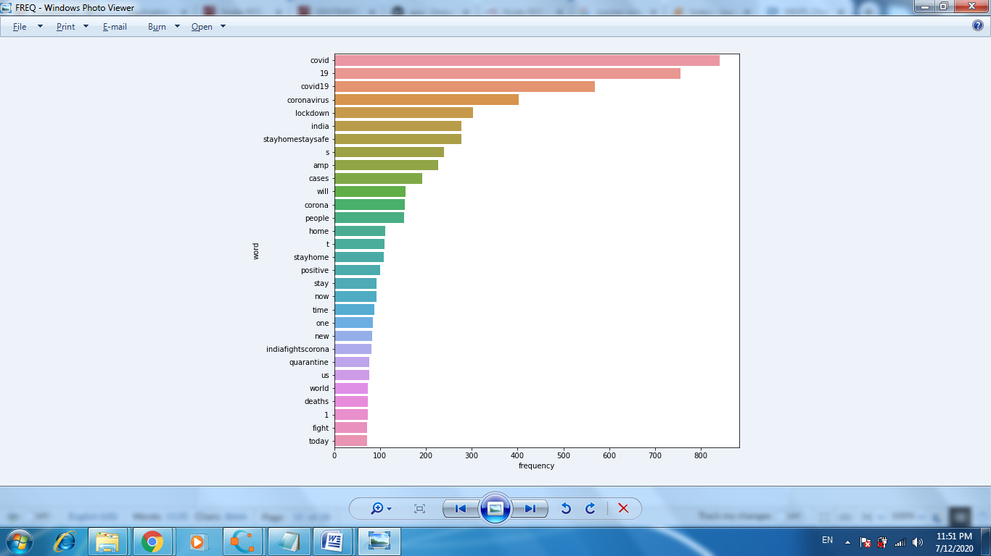

MY KAGGLE NOTEBOOK LINK :

<https://www.kaggle.com/naveenmsd/covid19-sentiment-analysis?scriptVersionId=38613088>

M4)STUDY OF NODE-RED:

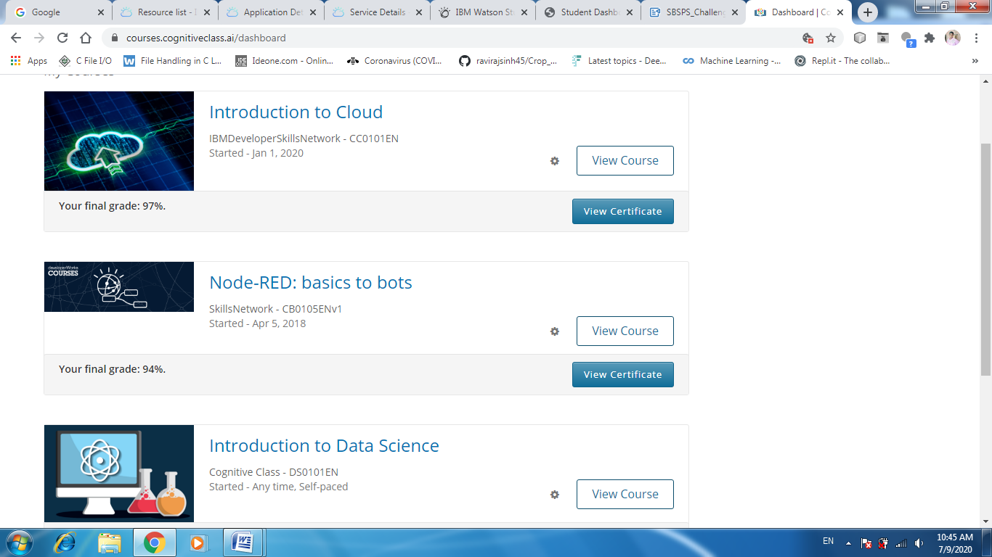

M5)BUILDING VISUALIZATION DASHBOARD

1)HOME PAGE

Node-red flows

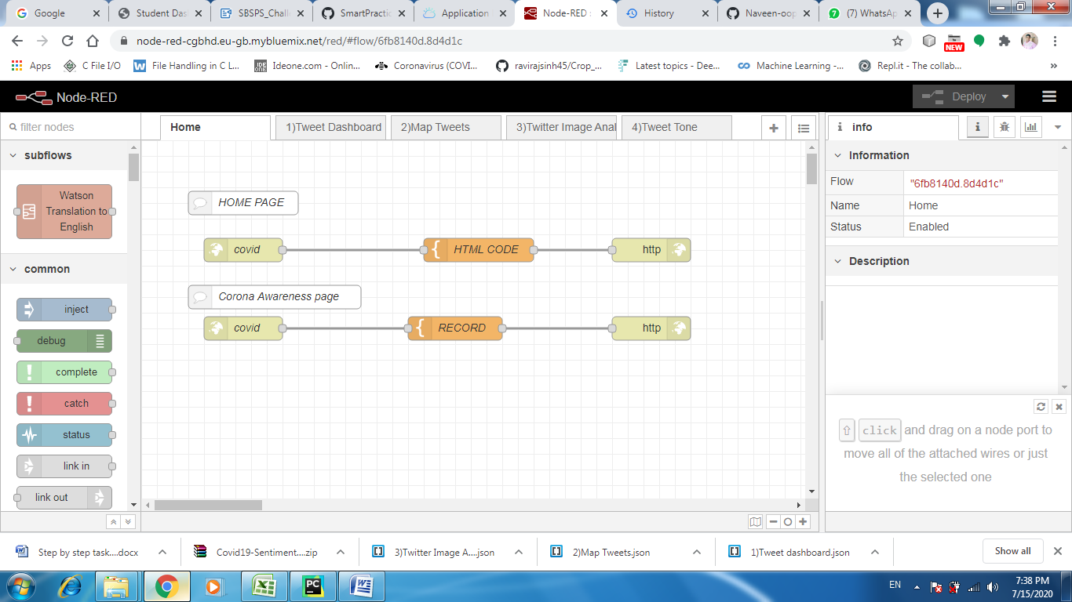

Designing Html code in Brackets IDE:

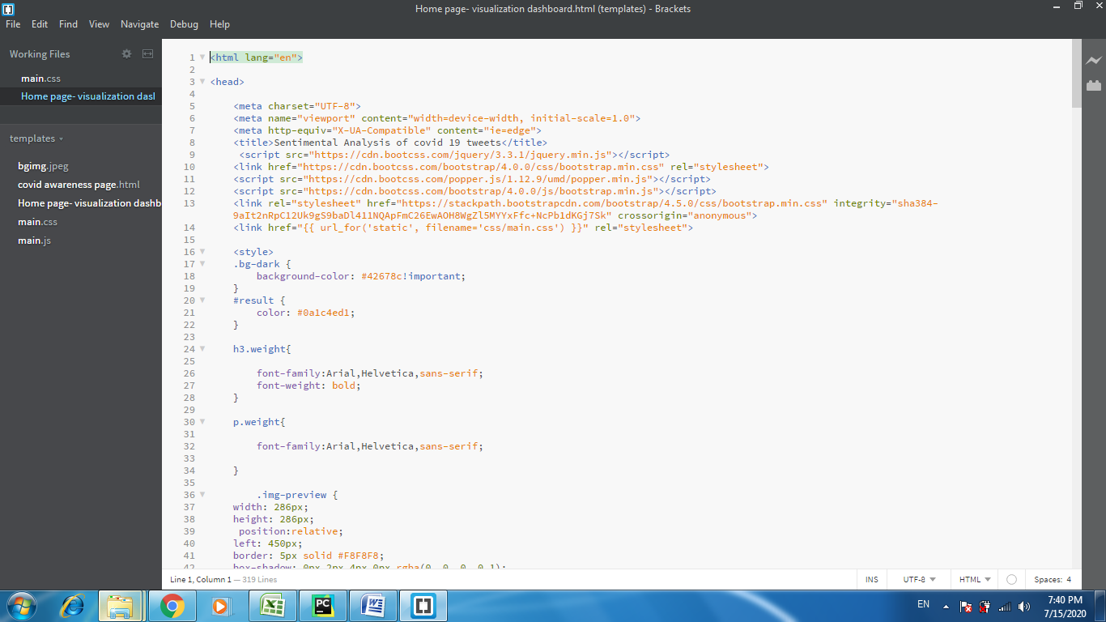

Pasting the final html code in Template node:

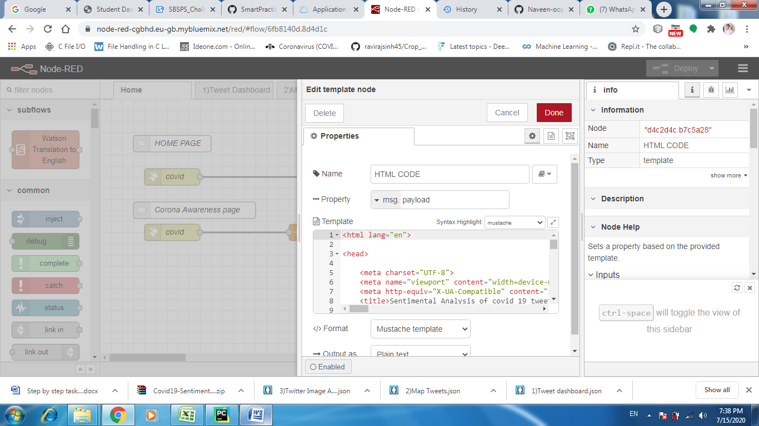

outputs:

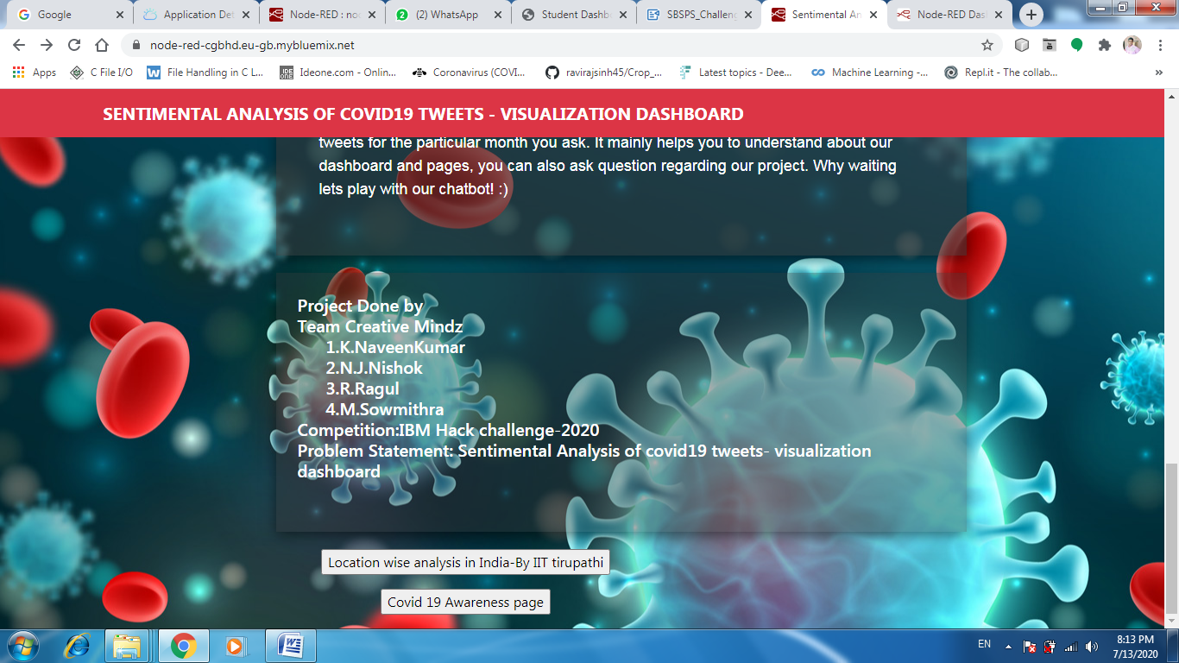

(Additional)corona Awarness page:

Desiging Html page in Bracket IDE:

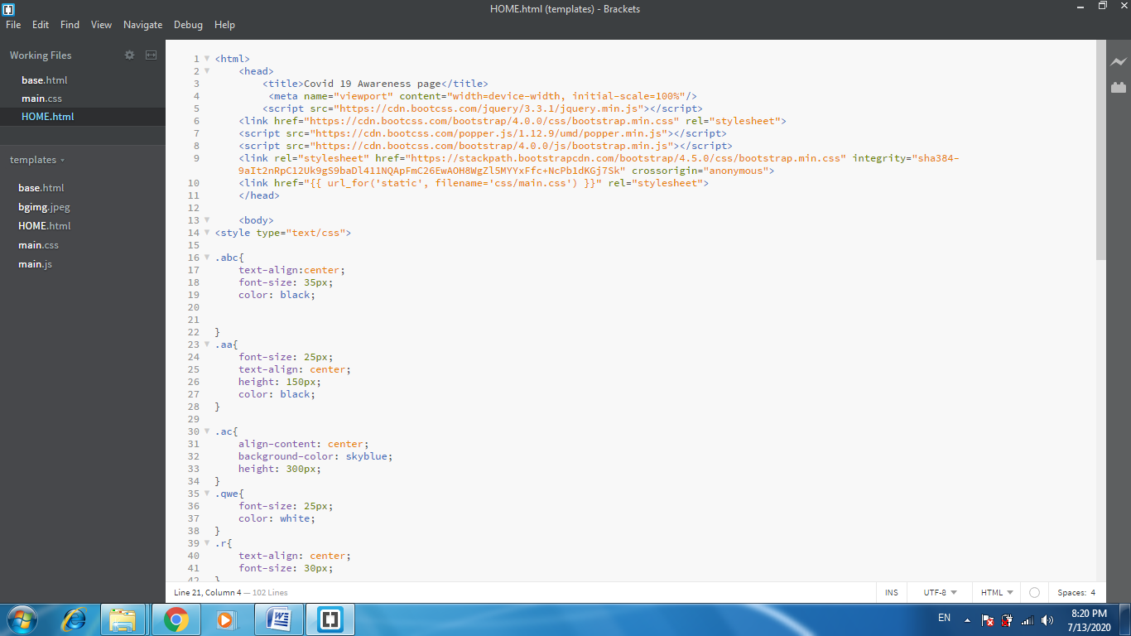

output:

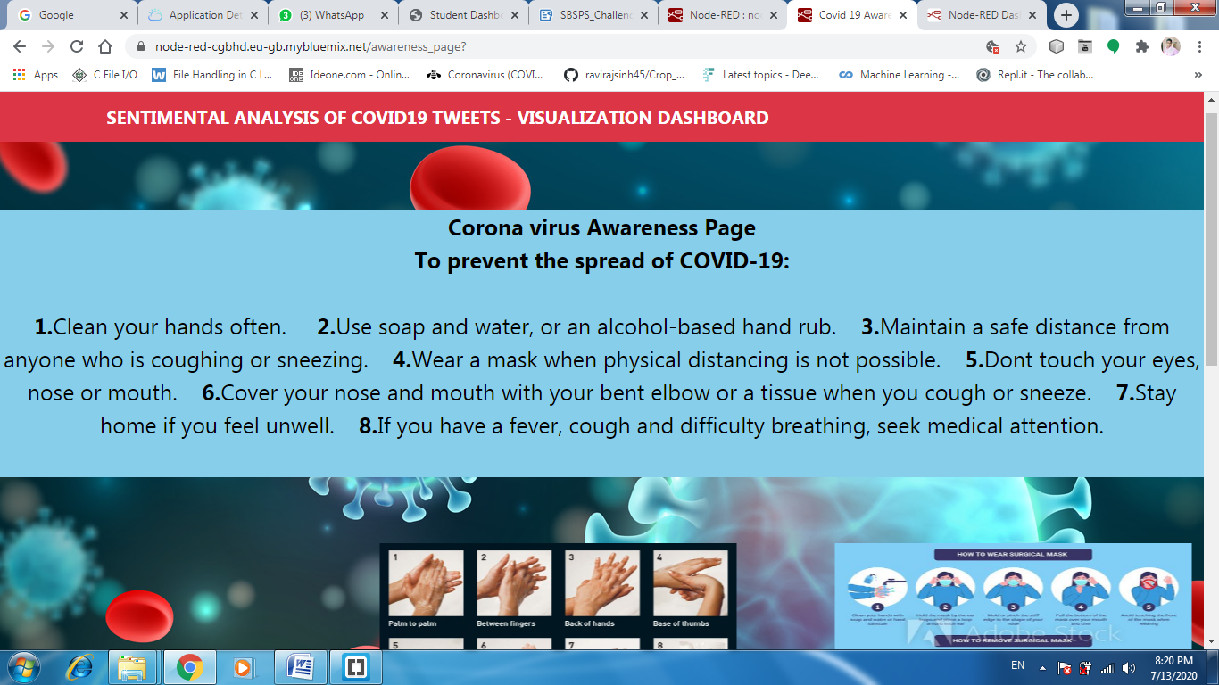

Awareness video:

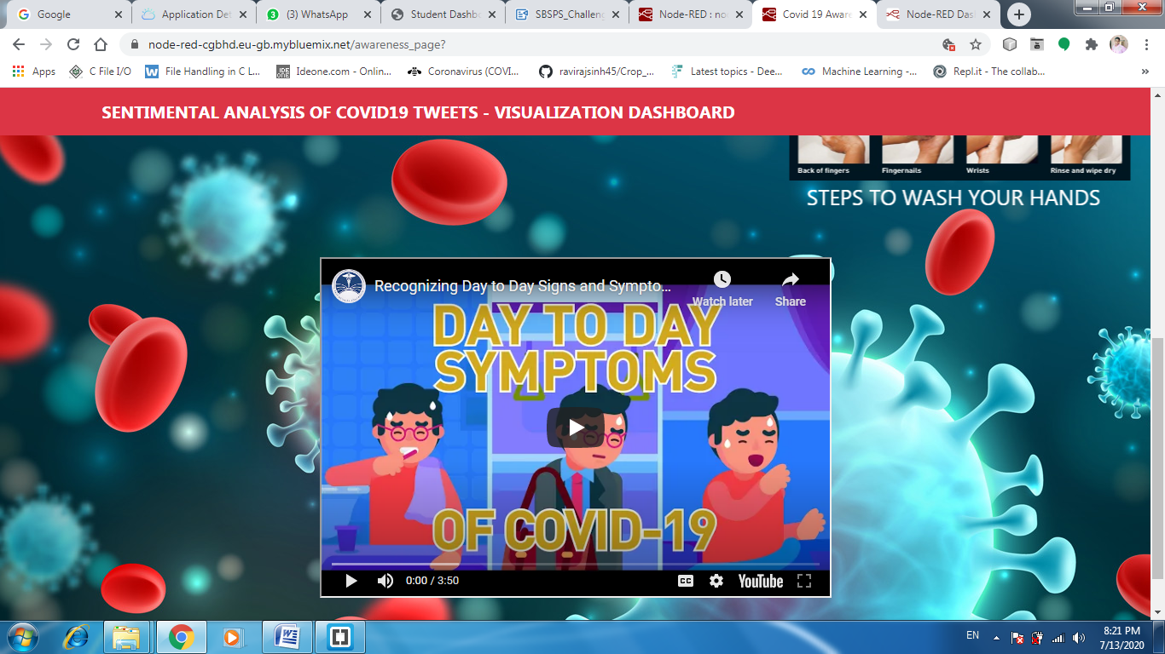

**2)DESIGNING VARIOUS TABS**

**Main Three sections:**

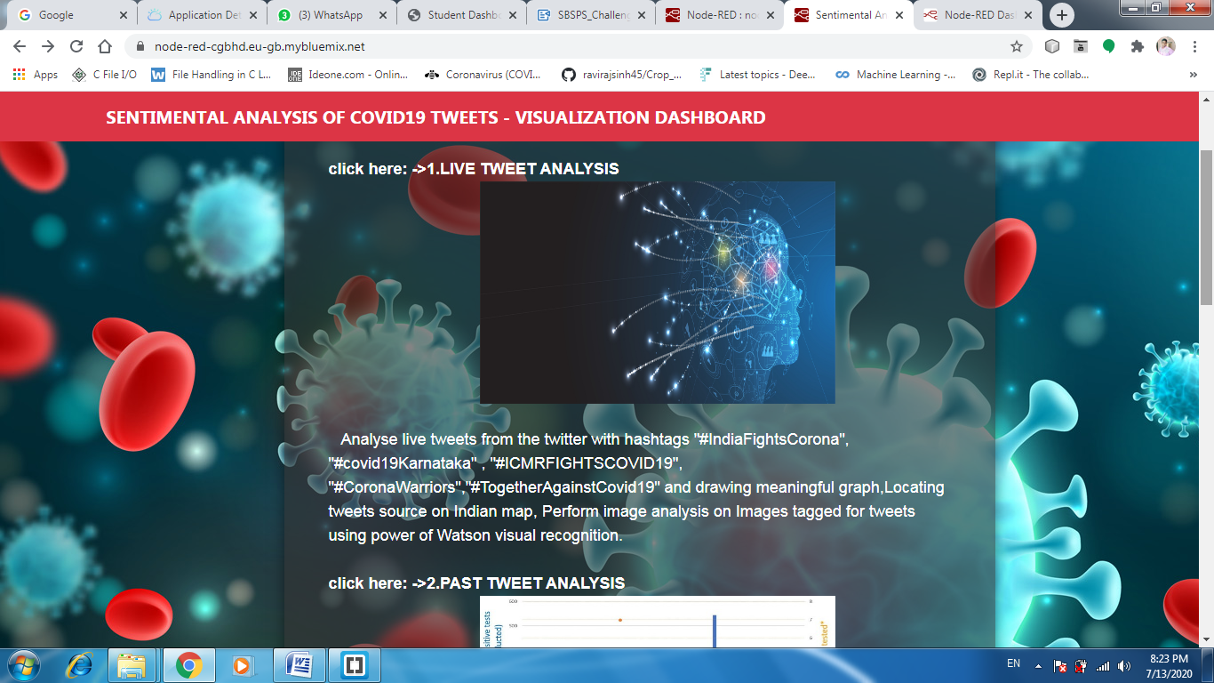

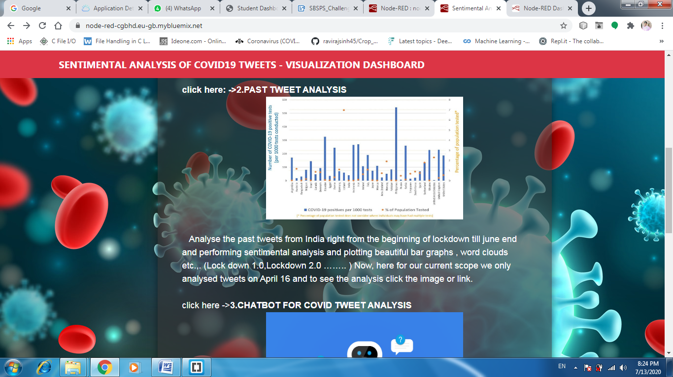

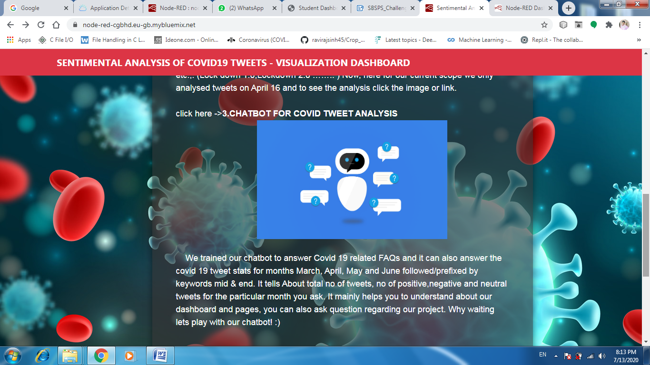

LIVE TWEETS

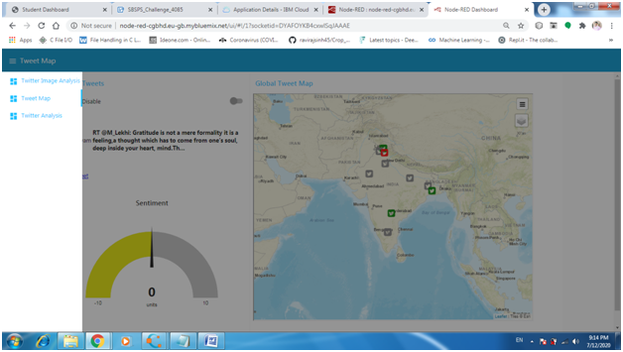

PAST TWEETS

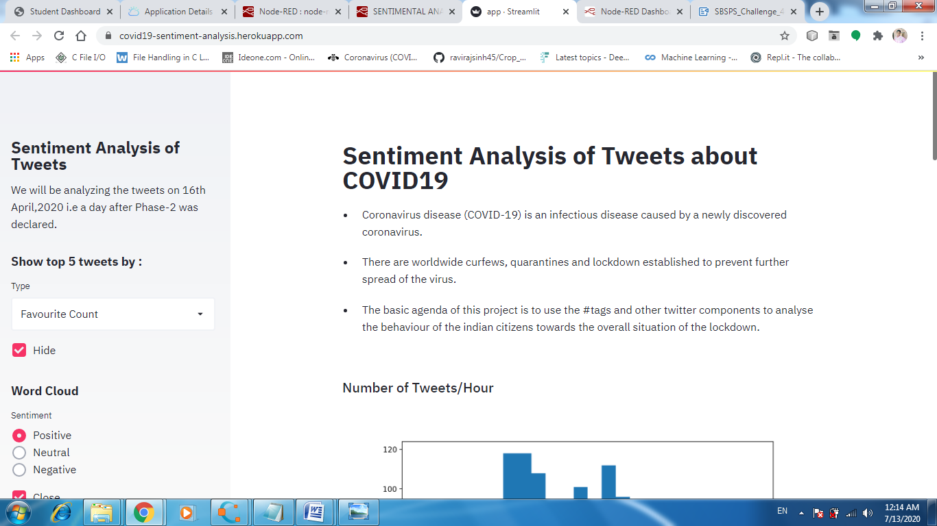

LIVE SENTIMENTAL ANALYSIS:

1)TWEET DASHBOARD:

**HASHTAGSUSED:**"#IndiaFightsCorona","#covid19Karnataka","#ICMRFIGHTSCOVID19", "#CoronaWarriors","#TogetherAgainstCovid19"

NODE-RED FLOW:

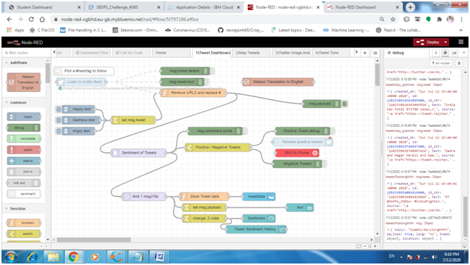

OUTPUT:

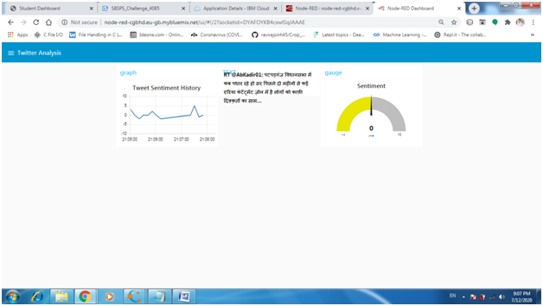

 2)TWITTER IMAGE ANALYSIS

NODE-RED FLOW:

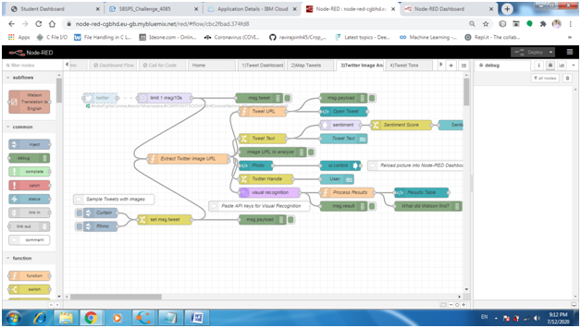

OUTPUT:

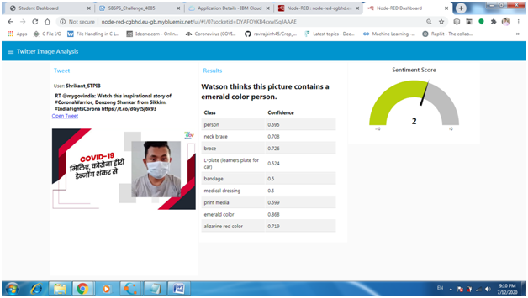

3)MAP TWEETS

NODERED FLOW:

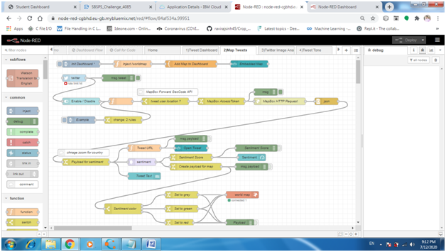

OUTPUT:

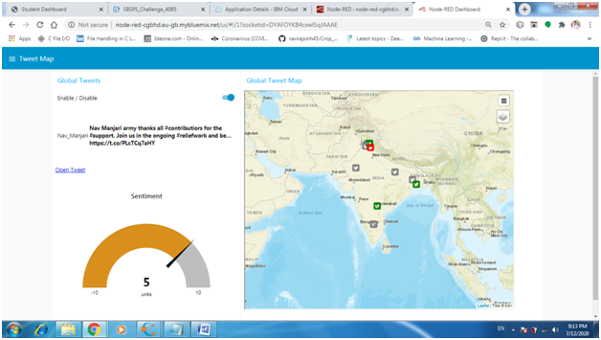

M-6)BUILDING A CHATBOT

QUESTION SETS:

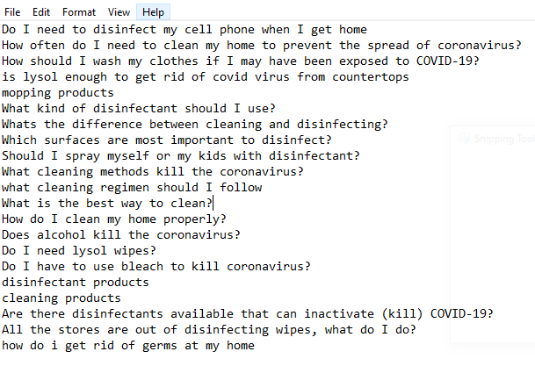

CREATING INTENTS AND ENTITIES

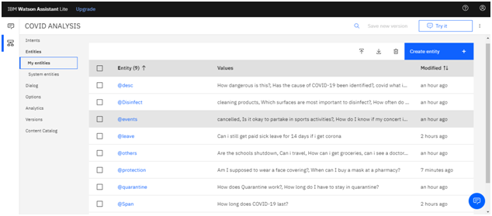

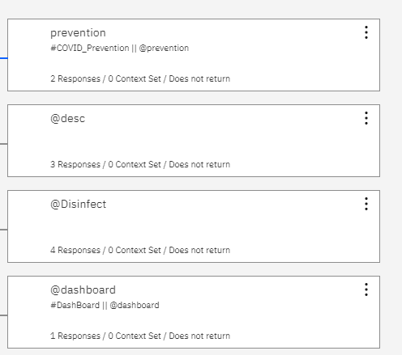

TRAINING THE CHATBOT

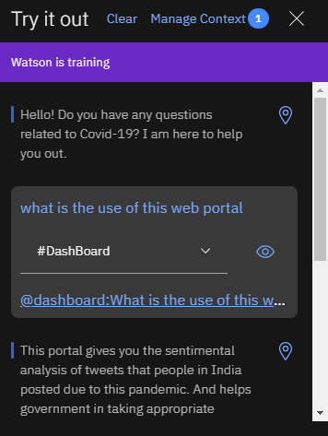

                                       M-7)INTEGRATING WITH CHATBOTS

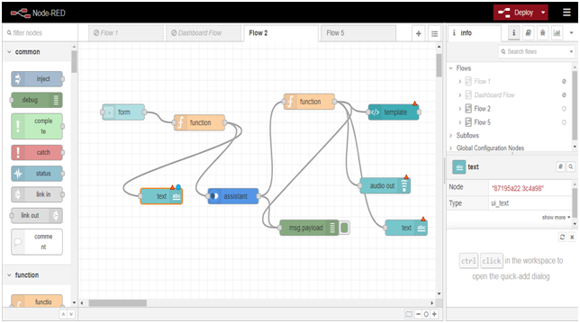

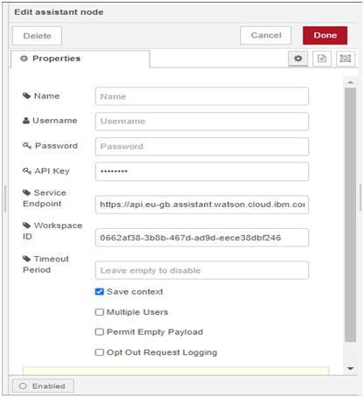

output:

Sample Qn(Related to covid 19 FAQs)

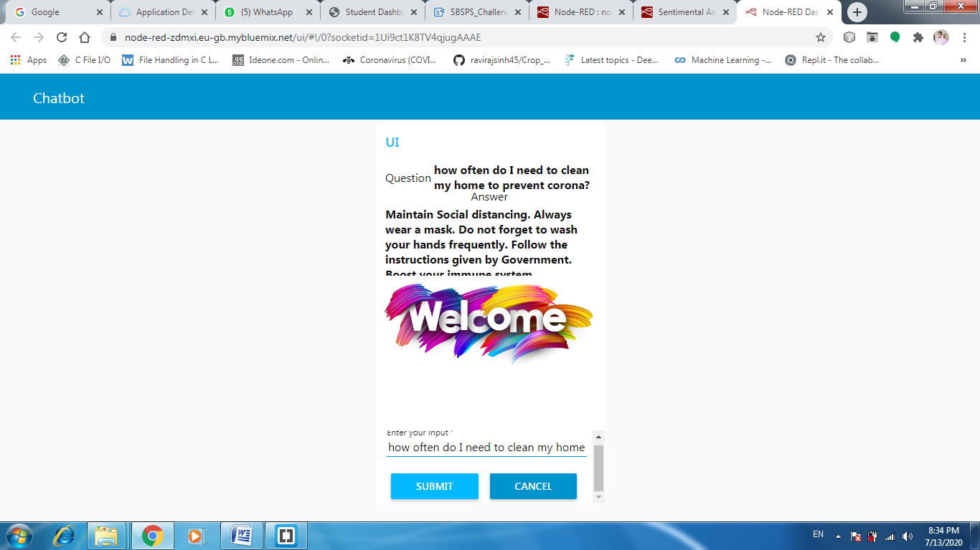

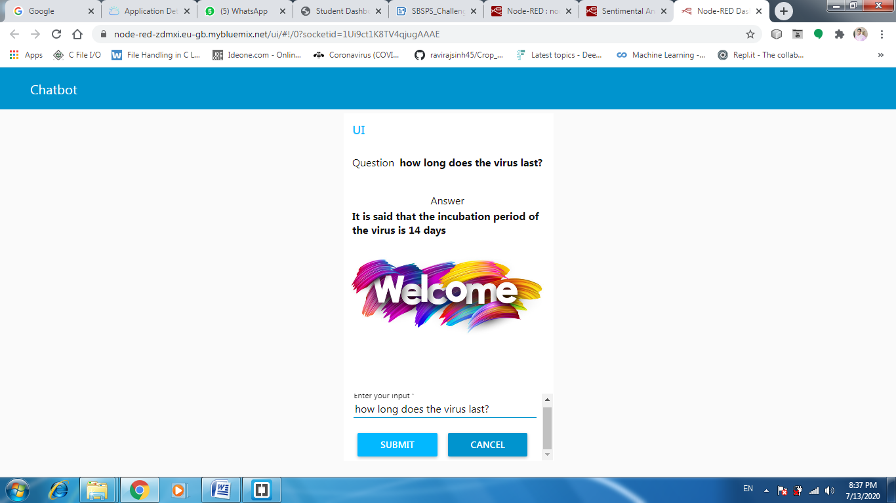

Question about our web portal:

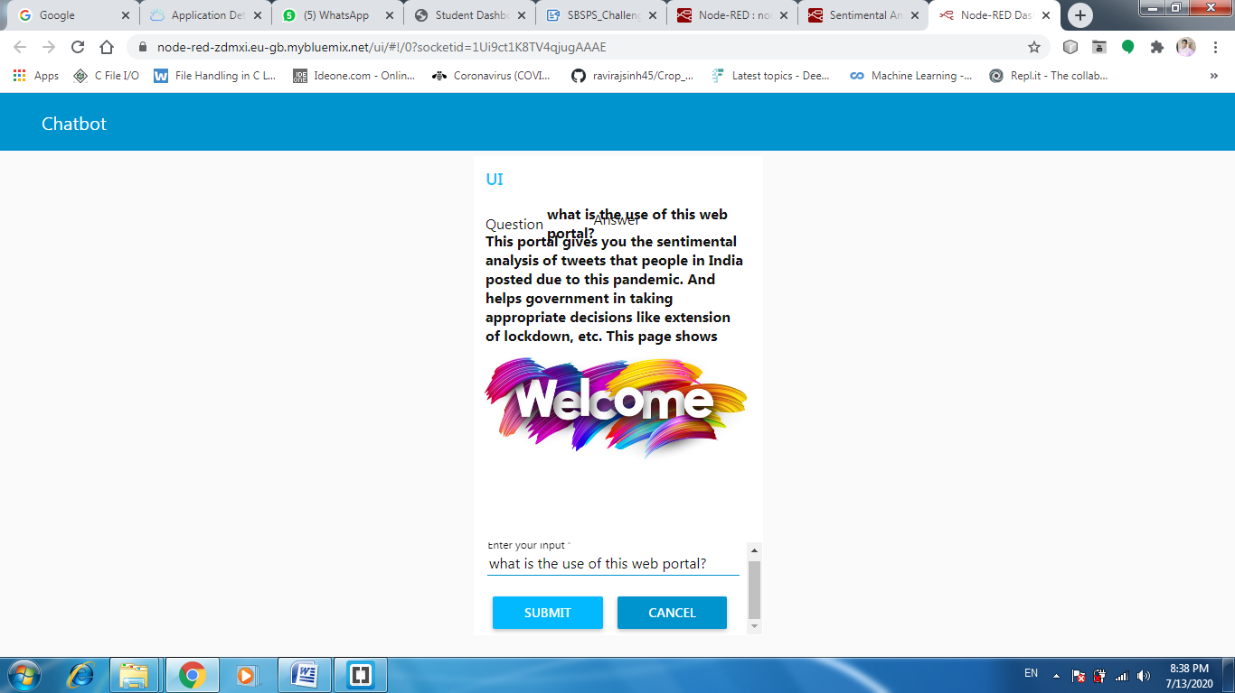

Chatbot telling stats about covid19 tweets:

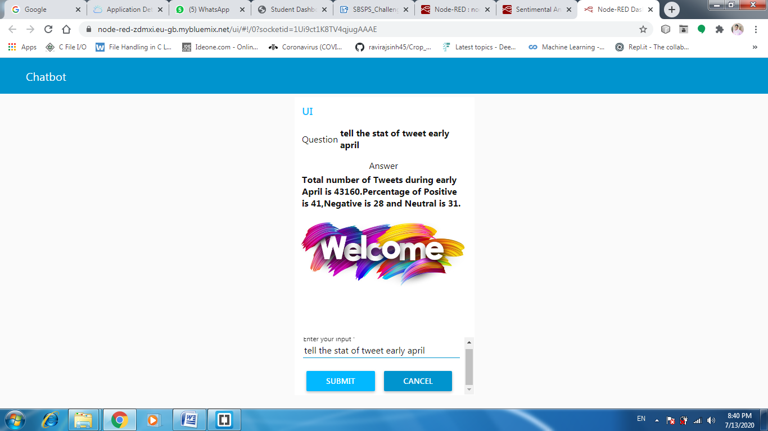

Additional features:

Hyper link to Location wise tweet analysis in India by IIT tirupathi

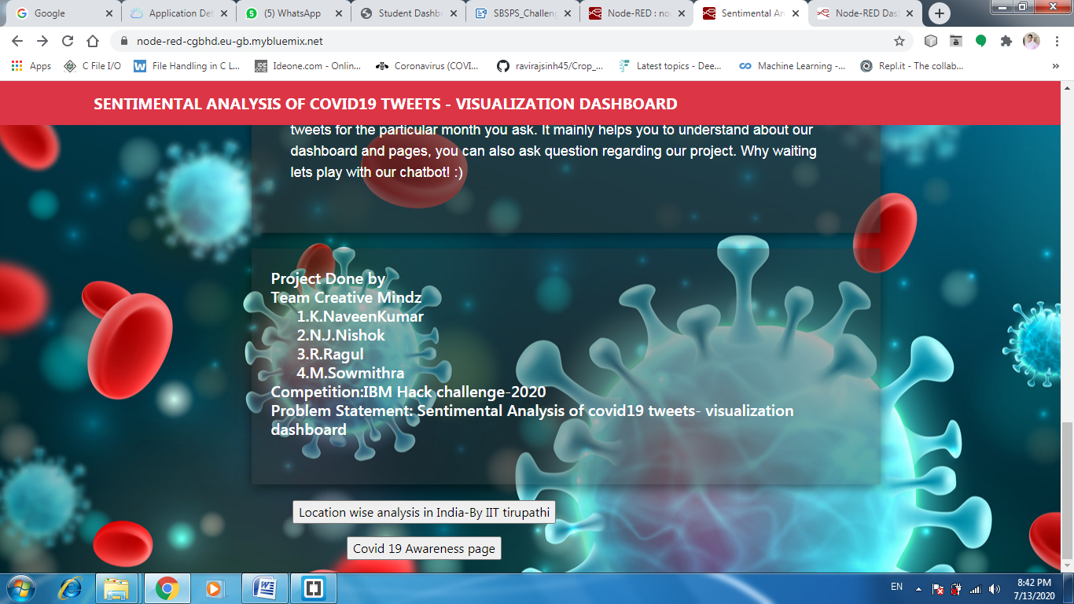

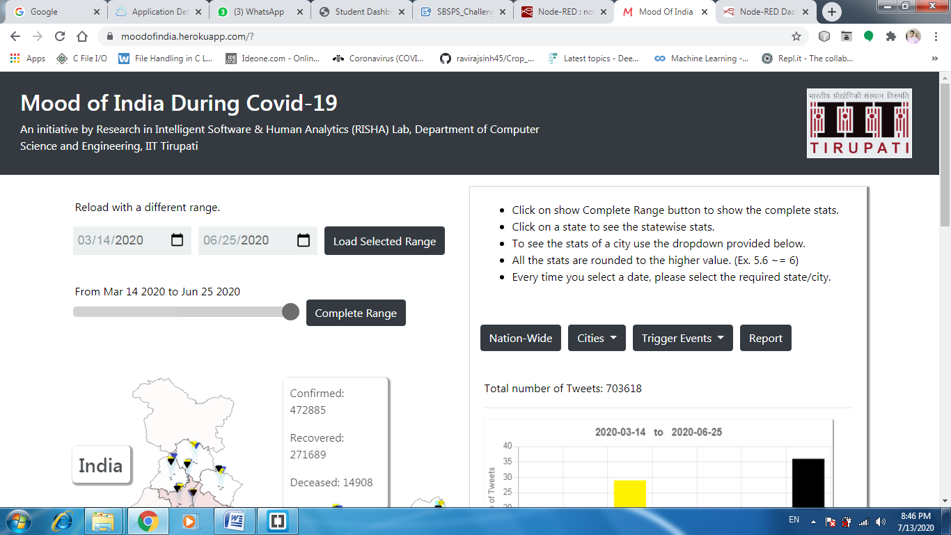

overall India sentimental analysis:(In 5 tones-Anger,Disgust,Happy,surprise,sad,neutral)

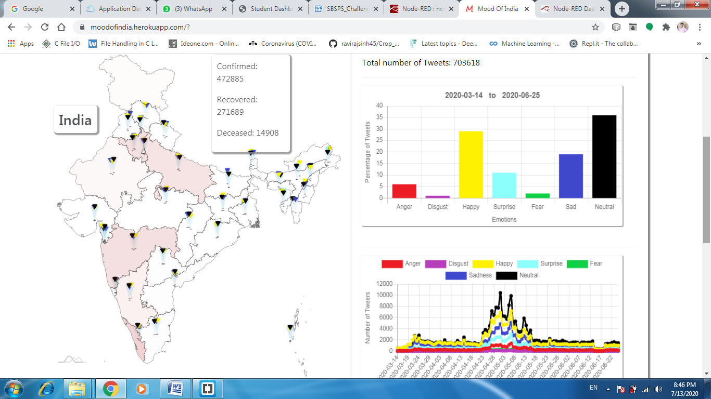

In particular state Maharashtra on(25 june):

